### **Stakeholder Review Report**

### **1. Introduction**

This report summarizes the research findings, recommendations, and proposed solutions for improving the voice quality and user interaction of the AIgents used by BizBridge. The aim is to enhance the user experience by implementing more lifelike and engaging AI voices, reducing response times, and ensuring the platform is scalable and secure.

### **2. Research Findings**

#### **2.1 User Stories and Acceptance Criteria -**

[**https://docs.google.com/document/d/1bCT7t6xFXGcF054fJVOkUiYY2doxOrvwGCDC9Lv6zJ8/edit?usp=drive_link**](https://docs.google.com/document/d/1bCT7t6xFXGcF054fJVOkUiYY2doxOrvwGCDC9Lv6zJ8/edit?usp=drive_link)

**User Stories**:

* **Uploading Forms**: Users need to upload various business documents for AI analysis.
* **Initiating Dialogues**: Users interact with AIgents through text or voice commands for business-related queries.
* **Receiving AI-Generated Outputs**: Users receive detailed reports and recommendations from AIgents.
* **Voice Interaction**: Users prefer natural and efficient voice interactions with AIgents.
* **User Feedback**: Users provide feedback to improve AIgents' accuracy and helpfulness.

**Acceptance Criteria**:

* **Uploading Forms**: Supports multiple file formats, validates file type and size, and ensures secure storage.
* **Initiating Dialogues**: Quick response times, context-aware, and logs conversations for future reference.
* **Receiving AI-Generated Outputs**: Fast generation of clear and concise reports with highlighted insights.
* **Voice Interaction**: Accurate recognition and processing of voice commands, with responses in clear and natural sounding voices.
* **User Feedback**: Easy access to feedback forms, categorized feedback, and regular updates based on user input.

#### **2.2 Initial Architecture Design -**

[**https://docs.google.com/document/d/1KwB-MGubexCMkWhYbiLFoU0E1EGPLjRxvkAPfj-u9tY/edit?usp=drive_link**](https://docs.google.com/document/d/1KwB-MGubexCMkWhYbiLFoU0E1EGPLjRxvkAPfj-u9tY/edit?usp=drive_link)

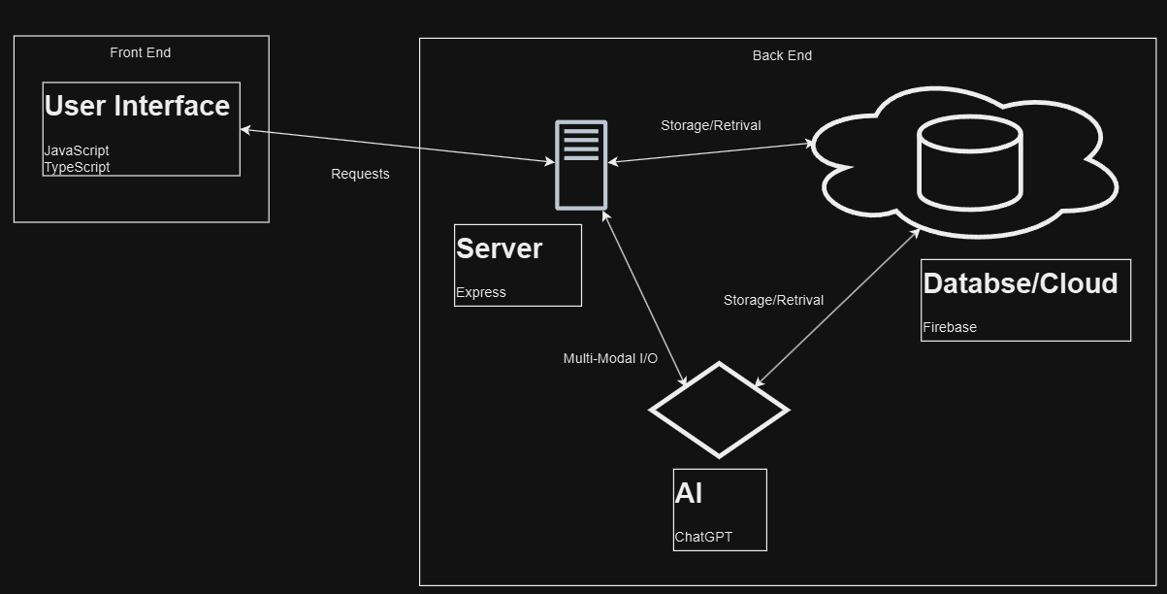

**System Components**:

* **User Interfaces**: Built with ReactJS for responsiveness and interactivity.
* **Dialogue Management**: Managed by a chatbot interface using GPT-4.
* **AI Voice Synthesis**: Utilizes GPT-4 and Whisper for text and voice input handling.
* **Database**: Firebase for scalable and secure backend storage.
* **Cloud Services**: Hosted on Google Cloud Platform for scalability and reliability.

**Technical Requirements**:

* **Data Compliance**: Adheres to GDPR, CCPA, and PCI-DSS standards.
* **Security**: Implements multi-factor authentication and regular security checks.
* **Performance**: Ensures page load times under 2 seconds and API response times under 600ms.
* **Scalability**: Supports dynamic scaling based on user demand.

#### **2.3 Market Research -**

[**https://docs.google.com/document/d/1AO-FGNXM7I5ir94cqKn5D7sxolHKzTC0_HhuIwbewVA/edit?usp=sharing**](https://docs.google.com/document/d/1AO-FGNXM7I5ir94cqKn5D7sxolHKzTC0_HhuIwbewVA/edit?usp=sharing)

**Competitive Analysis**:

* **BizBuySell**: Strong market position with over 15 million monthly page views and 100,000+ successful sales. Key features include business listings, broker services, and market insights.
* **Usability Scores**: Good overall usability but with areas needing improvement, such as navigation flexibility and error message clarity.

**Industry Trends**:

* **Intelligent Automation**: Increasing use of cloud platforms for flexibility and scalability, and the trend towards low/no-code solutions for business users.
* **Multimodal AI Models**: The rise of AI models that integrate multiple data sources for more accurate and comprehensive responses.

#### **2.4 Feasibility Study -** [**https://docs.google.com/document/d/1bclRXUlABM5MP7xsXdpcmTANeYeK8cZNzi9mLawS-QI/edit?usp=sharing**](https://docs.google.com/document/d/1bclRXUlABM5MP7xsXdpcmTANeYeK8cZNzi9mLawS-QI/edit?usp=sharing)

**Technology Stack**:

* **AI Models**: ChatGPT rated highest for feasibility due to its advanced capabilities and extensive support, despite being closed source.
* **APIs and Frameworks**: ReactJS, TypeScript, and Express recommended for front-end and back-end development. Firebase suggested for backend with considerations for cost management.

**Operational Feasibility**:

* **Scalability**: Horizontal scaling for servers and auto-scaling for databases.
* **Infrastructure**: Cloud hosting with load balancers for efficient traffic management.
* **Maintenance**: Regular updates and monitoring tools like New Relic or Grafana.
* **Support**: Dedicated technical and user support systems.

#### **2.5 Risk Analysis and Mitigation -**

[**https://docs.google.com/document/d/1JoI5W_EzSk0Sihonowa3gYxnEKgtkH_4FN3iGrOj0QU/edit?usp=drive_link**](https://docs.google.com/document/d/1JoI5W_EzSk0Sihonowa3gYxnEKgtkH_4FN3iGrOj0QU/edit?usp=drive_link)

**Key Risks**:

* **Technical Risks**: Integration complexities with ReactJS, GPT-4, Whisper, and Firebase; AI model inaccuracies.
* **Operational Risks**: Challenges with closed source tools, scalability issues.
* **Market Risks**: User security concerns, non-compliance with data protection standards, and potential data breaches.

**Mitigation Strategies**:

* **Technical**: Training for developers, rigorous testing of AI outputs, and detailed documentation.
* **Operational**: Thorough research and validation of tools, scalable architecture design, and regular security audits.
* **Market**: Robust security measures, clear communication of security protocols, and compliance audits.

### **3. Recommendations**

1. **Implement ChatGPT**: Leverage ChatGPT for its advanced capabilities and support despite being closed source. It provides the best balance between performance and functionality for the AIgents.
2. **Optimize System Performance**: Focus on reducing response times and ensuring seamless integration of all system components. Regular performance testing and optimization should be prioritized.
3. **Enhance Voice Interaction**: Use advanced voice synthesis technologies like Whisper to create lifelike and engaging AI voices. Ensure the voices have distinct personalities to improve user relatability.
4. **Ensure Scalability and Security**: Design the system to support dynamic scaling and implement strong security measures. Regular security checks and compliance with data protection standards are essential.
5. **Incorporate User Feedback**: Establish a robust feedback mechanism to continuously improve AI performance and user satisfaction. Regular updates based on user feedback will help maintain high-quality interactions.

### **4. Proposed Solutions**

1. **Technical Implementation**: Use ReactJS, TypeScript, and Express for front-end and back-end development. Firebase for backend storage with cost management strategies. Google Cloud Platform for hosting and scalability.
2. **Voice Quality Improvement**: Integrate Whisper for natural sounding voice responses. Conduct user testing to refine voice characteristics and ensure they align with user expectations.
3. **Performance Optimization**: Implement load balancers, edge computing for reduced latency, and regular performance monitoring tools.
4. **User Experience Enhancement**: Develop a user friendly interface with clear navigation, easy access to forms and reports, and comprehensive conversation summaries.
5. **Risk Management**: Develop detailed contingency plans for identified risks, including technical support for integration challenges and legal support for compliance issues.

### **5. Conclusion**

By addressing the key findings from the research and following the proposed recommendations and solutions, BizBridge can significantly enhance the user experience of their AIgents. Implementing advanced voice synthesis, optimizing system performance, and ensuring scalability and security will lead to higher user satisfaction and a more robust platform.